SUMMER CAMP 2022
MONDAY 4  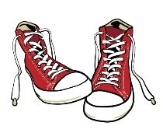 | TUESDAY 5  Confederation Water Park/Picnic  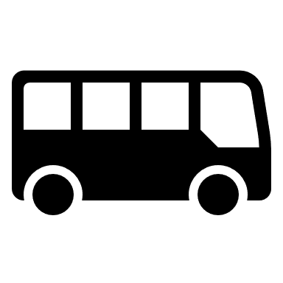 | WEDNESDAY 6 | THURSDAY 7  Stanley Park Beach/Water Park | FRIDAY 8  Pizza day!  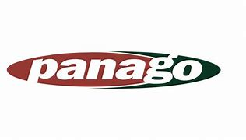
MONDAY 11  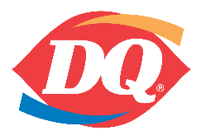 | TUESDAY 12 | WEDNESDAY 13  Britannia Mine Museum | THURSDAY 14  Beach Day | FRIDAY 15  Maritime Museum
MONDAY 18 | TUESDAY 19  Bill Reid Gallery | WEDNESDAY 20 | THURSDAY 21  Museum of Anthropology | FRIDAY 22  Hamburger day!  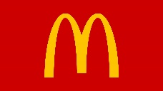  (Mc Donald’s anyone?)
MONDAY 25  Grouse Mountain | TUESDAY 26  Slurpee-Beach!  COMBO! | WEDNESDAY 27  Jericho Beach | THURSDAY 28 | FRIDAY 29
MONDAY 1  CLOSED BC DAY | TUESDAY 2  Whytecliff Park | WEDNESDAY 3 | THURSDAY 4  Capilano Salmon Hatchery | FRIDAY 5  Pizza day!
MONDAY 8  North Vancouver Waterfront | TUESDAY 9 | WEDNESDAY 10  Sea To Sky Gondola | THURSDAY 11  Beach Day | FRIDAY 12
MONDAY 15  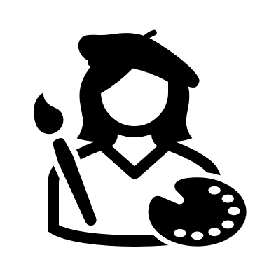 | TUESDAY 16  Ambleside Beach | WEDNESDAY 17  Sports and games | THURSDAY 18  Capilano suspension Bridge | FRIDAY 19  Hamburger day!  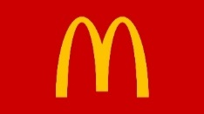  (Mc Donald’s anyone?)
MONDAY 22  Cates Park | TUESDAY 23 | WEDNESDAY 24  Queen Elizabeth | THURSDAY 25 | FRIDAY 26
MONDAY 29 | TUESDAY 30  Bowen Island | WEDNESDAY 31  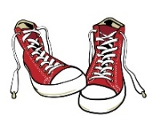 | THURSDAY 1  Lighthouse Park | FRIDAY 2  Pizza day  