MONDAY 5  Welcome Summer  Magician Party | TUESDAY 6  Beach day | WEDNESDAY 7  Sprots and games | THURSDAY 8  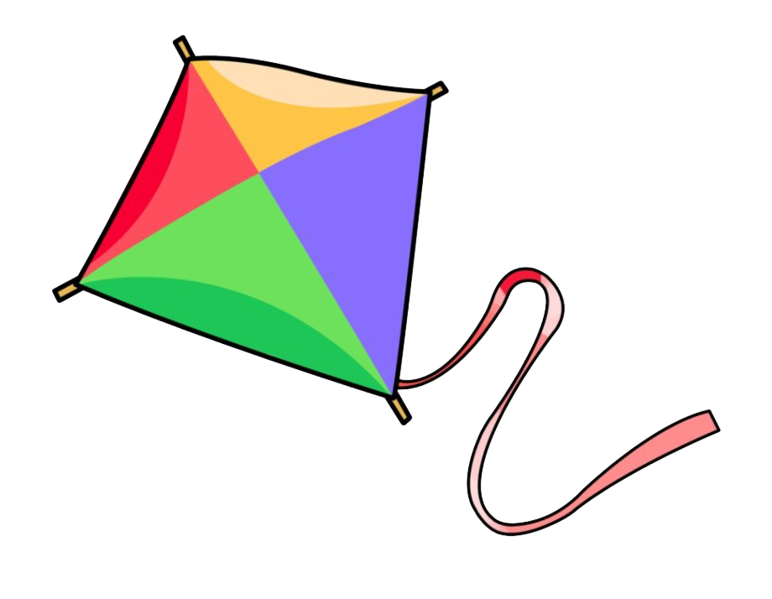  This Photo by Unknown Author is licensed under CC BY-NC  Kite making | FRIDAY 9  Pizza day!
MONDAY 12  Arts  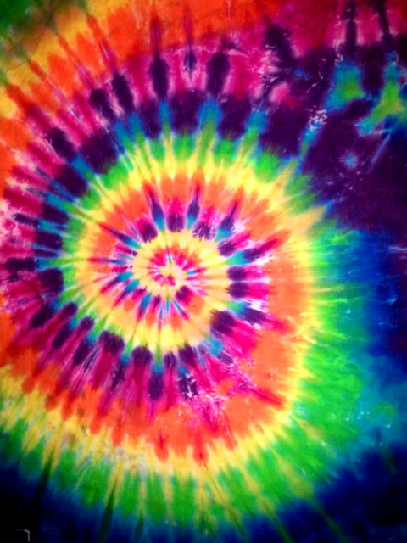  This Photo by Unknown Author is licensed under CC BY  Tide-Dye shirts | TUESDAY 13  HR MacMillan Space Center zoom workshop | WEDNESDAY 14  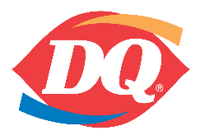  Ice Cream Day! | THURSDAY 15  Beach Day | FRIDAY 16  Hamburger day!  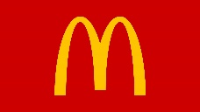  (Mc Donald’s anyone?)
MONDAY 19  Beach Day | TUESDAY 20  Making volcanoes | WEDNESDAY 21 | THURSDAY 22  Arts and crafts  Paint your own canvas | FRIDAY 23  SUBWAY DAY  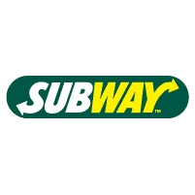
MONDAY 26  Arts  Making puppets workshop | TUESDAY 27  Slurpee-Magician!  COMBO! | WEDNESDAY 28  Beach Day | THURSDAY 29 | FRIDAY 30  Hamburger day!  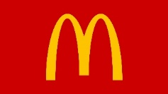  (Mc Donald’s anyone?)
MONDAY 2  CLOSED BC DAY | TUESDAY 3  Beach Day | WEDNESDAY 4  Sports and games | THURSDAY 5  Arts and Crafts  Make beaded wind chimes | FRIDAY 6  Pizza day!
MONDAY 9  Dairy Queen | TUESDAY 10  HR MacMillan Space Center zoom workshop | WEDNESDAY 11  BELLA CERAMICA | THURSDAY 12  Beach Day | FRIDAY 13  SUBWAY DAY
MONDAY 16  Rocket ships  Science | TUESDAY 17  Beach Day | WEDNESDAY 18  Sports and games | THURSDAY 19  CLAY WORKSHOP | FRIDAY 20  Hamburger day!  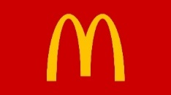  (Mc Donald’s anyone?)
MONDAY 23  Arts  This Photo by Unknown Author is licensed under CC BY  Tide-Dye | TUESDAY 24  Bikes | WEDNESDAY 25  Beach Day | THURSDAY 26  Science  Chemical reactions! | FRIDAY 27  Pizza day!
MONDAY 30  Making Jewelry | TUESDAY 31  Combo!!  Slurpee-Magician! | WEDNESDAY 1  Sports and Games | THURSDAY 1  Beach Day | FRIDAY 3  Goodbye Summer

